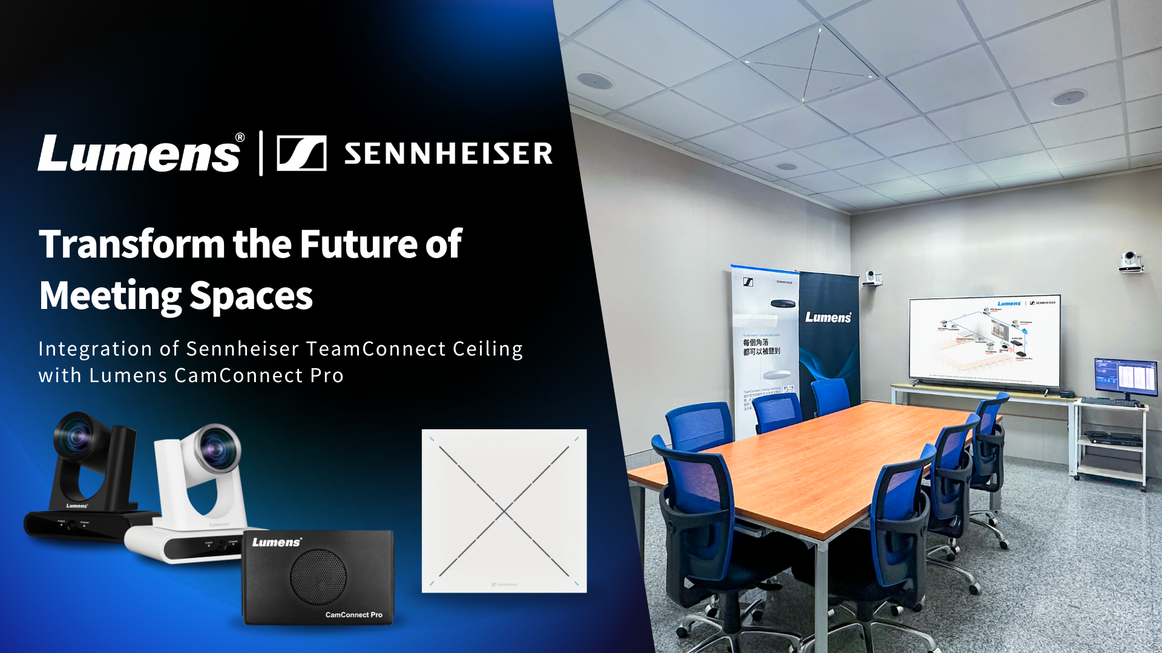

Sennheiser and Lumens partner to deliver the future of meeting spaces at Taiwan HQ
Partnership showcases seamless integration of TeamConnect Ceiling 2 with Lumens’ CamConnect Pro speaker tracking system

Wedemark, 18 July 2025 – Sennheiser, the first choice for advanced audio technology that makes collaboration easier, has partnered with Lumens Digital Optics Inc. to create a professional conferencing demo space at Lumens’ headquarters in Taiwan. The collaboration highlights the seamless integration of Sennheiser’s TeamConnect Ceiling 2 (TCC 2) with Lumens’ CamConnect Pro voice-tracking camera system – offering a smarter, more engaging conferencing experience.

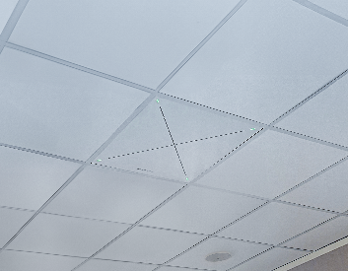 | Sennheiser’s TeamConnect Ceiling 2 (TCC 2) integrates seamlessly with Lumens’ CamConnect Pro voice-tracking camera system – offering a smarter, more engaging conferencing experience

The installation demonstrates how combining best-in-class audio and video technology can solve real-world AV challenges and deliver unprecedented meeting equity. Designed for effortless operation and simple deployment, the solution enables automatic camera tracking and precise voice pickup, significantly enhancing hybrid communication experiences.

Sennheiser’s TCC 2 is a ceiling array microphone featuring dynamic beamforming technology. It delivers an ultra-narrow and highly accurate voice capture beam, which detects the speaker’s position and transmits that location data to the Lumens system. This allows the cameras to automatically track and frame the active speaker, with no additional coding or complex configuration required.

Lumens’ CamConnect Pro is an advanced speaker tracking and auto-switching multi-camera processor. Equipped with AI for precise people tracking, the system autonomously controls up to four IP PTZ cameras, intelligently directing each shot and switching angles in real time to capture each speaker clearly and naturally.
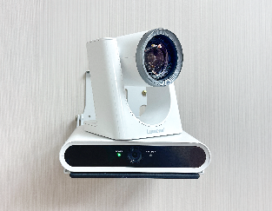
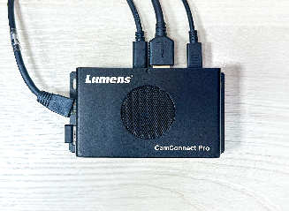
Left: CamConnect Pro / Right: VC-TR30 AI Auto-Tracking Camera－Lumens Products

The result is a scalable, easy-to-deploy solution suitable for a wide range of professional environments, including council chambers, boardrooms, classrooms, and auditoria. By automating production elements and reducing the need for manual control, the system enhances both meeting efficiency and inclusivity.

“This collaboration reflects our shared commitment to creating powerful, flexible conferencing solutions that support more inclusive and productive meetings,” says Jessica Wong, Business Communications Sales Lead, Hong Kong & Taiwan at Sennheiser. “The integration of our TeamConnect Ceiling 2 microphone with Lumens’ CamConnect Pro camera system delivers a seamless, high-performance experience that’s easy to deploy and manage.”

The integrated solution will be demonstrated live at InfoComm Asia 2025 in Bangkok, Thailand from 23–25 July. To see the system in action and learn more about how the integration works, watch the partner interview here:
https://www.youtube.com/watch?v=ak1J-Gs-qvE

For more information about the Lumens and Sennheiser integration solution, please visit:
https://www.mylumens.com/en/Page/83/Lumens-CamConnect-Pro-AI-Voice-Tracking-Camera-Solution-Sennheiser

For more information about Sennheiser and its solutions, visit www.sennheiser.com

About the Sennheiser Brand – 80 Years of Building the Future of Audio
We live and breathe audio. We are driven by the passion to create audio solutions that make a difference. This passion has taken us from the world’s greatest stages to the quietest listening rooms – and made Sennheiser the name behind audio that doesn’t just sound good: It feels true. In 2025, the Sennheiser brand celebrates its 80th anniversary. Since 1945, we stand for building the future of audio and bringing remarkable sound experiences to our customers. While professional audio solutions such as microphones, meeting solutions, streaming technologies and monitoring systems are part of the business of Sennheiser electronic SE & Co. KG, the business with consumer devices such as headphones, soundbars and speech-enhanced hearables is operated by Sonova Holding AG under the license of Sennheiser.

www.sennheiser.com
www.sennheiser-hearing.com

About Lumens
Lumens® Digital Optics Inc., a Pegatron Group company, is a leader in optical products. Lumens’ product offerings include CamConnect Pro, HD and 4K PTZ cameras, auto-tracking and auto-framing cameras, media processors, IP transmitters and decoders and document cameras. Founded in 1998, the company was created by a team with a deep technological heritage of image processing, video electronics, and optical technology. With the support of the Pegatron Group, Lumens is continuously improving product designs to be used in video studios, live events, classrooms, conference rooms, and for distance learning. For more information, visit Lumens website.

Global Sennheiser Contact
Jeffrey Horan
Global PR/Media Manager Business Communication
jeffrey.horan@sennheiser.com
+1 860-598-7539

